Trellis supply
How to build a deer fence Content

1-Three Essentials For A Good Fence
THREE ESSENTIALS FOR A GOOD FENCE: 1. Get professional guidance 2. Buy quality materials 3. Build according to the manufacturer’s recommendations PLANNING • Make sure you know where the property line is as existing...

2-Plan Your Fence
Planning your fence thoroughly is the easiest way to ensure that your fencing project goes as smoothly and economically as possible. Sketch out a map of your property. Designate different land use areas—grazing acreage,...

3-Gather the Right Tools
Our tools are designed to work with our fencing to make the installation process as easy and trouble-free as possible. We recommend using two stretcher bars and pulling the wire to the center. Splicing...

4-Lay Out The Fence Line and Set Posts
LAYOUT THE FENCE LINE AND SET POSTS Prepare the Fence Line The fence line should be cleared and clean before starting the fence. The optimum width for your cleared fence line should be..

5-Build the End Braces
BUILD THE END BRACES Note: these instructions are for wood end braces. Measure and cut cross-memberMeasure and cut the cross-member so it will fit between the tops of the brace posts. Figure height of...

6-Tie the Wire to the End Braces
TIE THE WIRE TO THE END BRACES Roll out the fencePosition the roll of fence wire near an end brace. Roll out about 50 feet of fence. Roll out 50 feet of wirePut something...

7-Tighten the Fence
TIGHTEN THE FENCE Attach the fence wire to the stretcher barsPosition a stretcher bar under the fence between 10 to 15 feet apart, depending on the length of the pull. Both fence ends require...

8-Splice the Fence
SPLICE THE FENCE Cut the fence wire. Tighten the top or bottom stretcher bar as needed to square up the vertical wire stays in the fencing. At this point one stretcher bar should be...

9-Trim The Fence Out
TRIM THE FENCE OUT Staple the fence to the wooden fence postsStaple and clip the fence from the ground up if you are trying to control predators. If you are trimming the fence to...

10-The Finished Fence
THE FINISHED FENCE The finished Stay-Tuff high tensile fence If you have followed all our instructions, you can look forward to a maintenance-free fence that will last at least 25 years. The fence constructed..
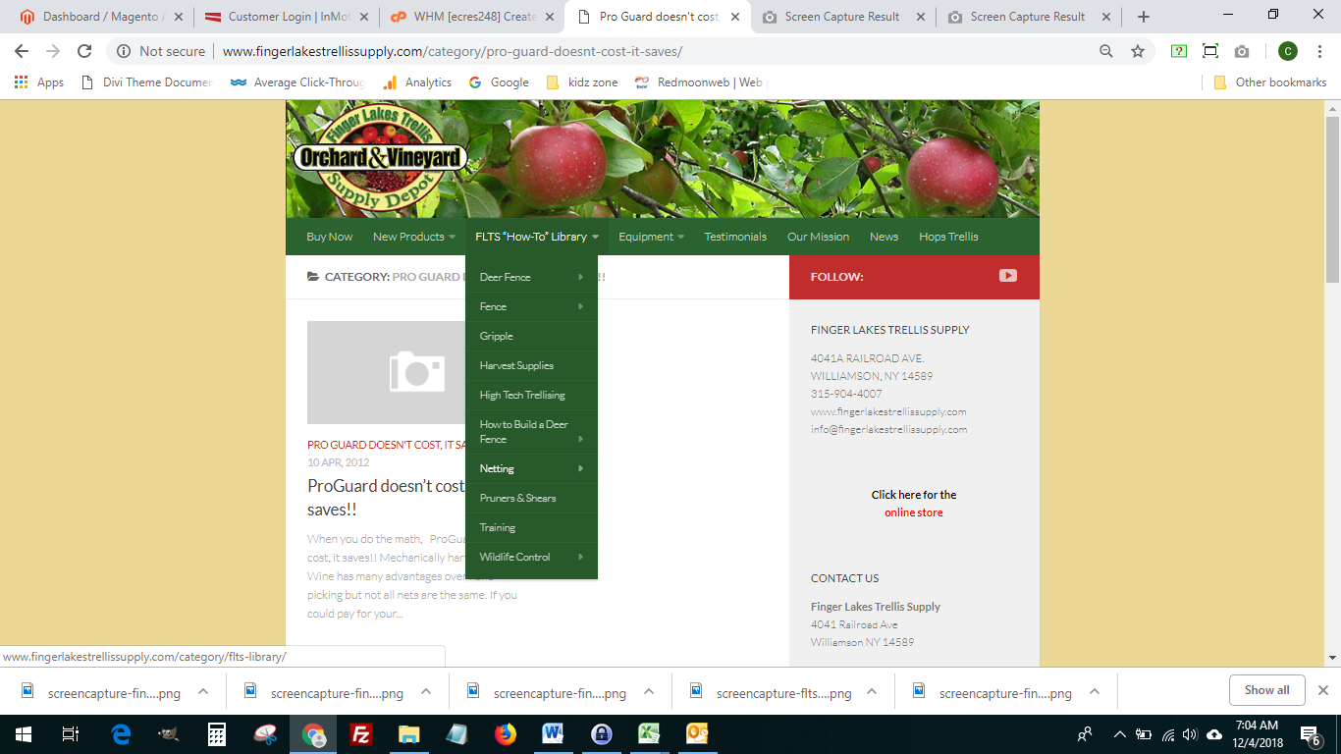

OUR MISSION
Finger Lakes Trellis Supply will remain a recognized distributor of specialty supplies and services to the Orchard, Vineyard and Hops industries throughout the United States and Canada.
Finger Lakes Trellis Supply will continue to develop strong relationships with key customers and suppliers in order to be viewed as indispensable partners, rather than just another supplier. We work closely with each customer to recommend products unique to their application. Finger Lakes Trellis Supply seeks out and works with suppliers and manufacturers we represent to deliver the most innovative and exciting products possible to the customers we serve. We are not only selling superior products, we are selling superior service.

HOPS TRELLIS
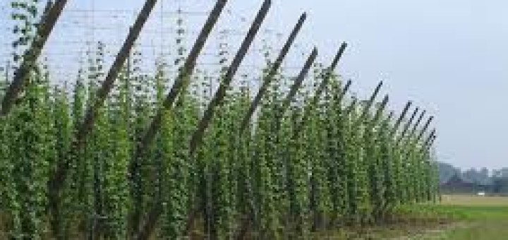
Building a successful hops farm starts with proper installation of your hops trellis support system. Creating the optimal hop yard that produces maximum yields with minimal infrastructure, labor, and inputs is critical to long term success & profitability of a hop yard. Building a small scale commercial hop trellis is a huge undertaking. Even a small project requires a lot of planning, good communication skills, management of time and financial details. We can supply you with all the materials and advise you need to start your successful hops farm

